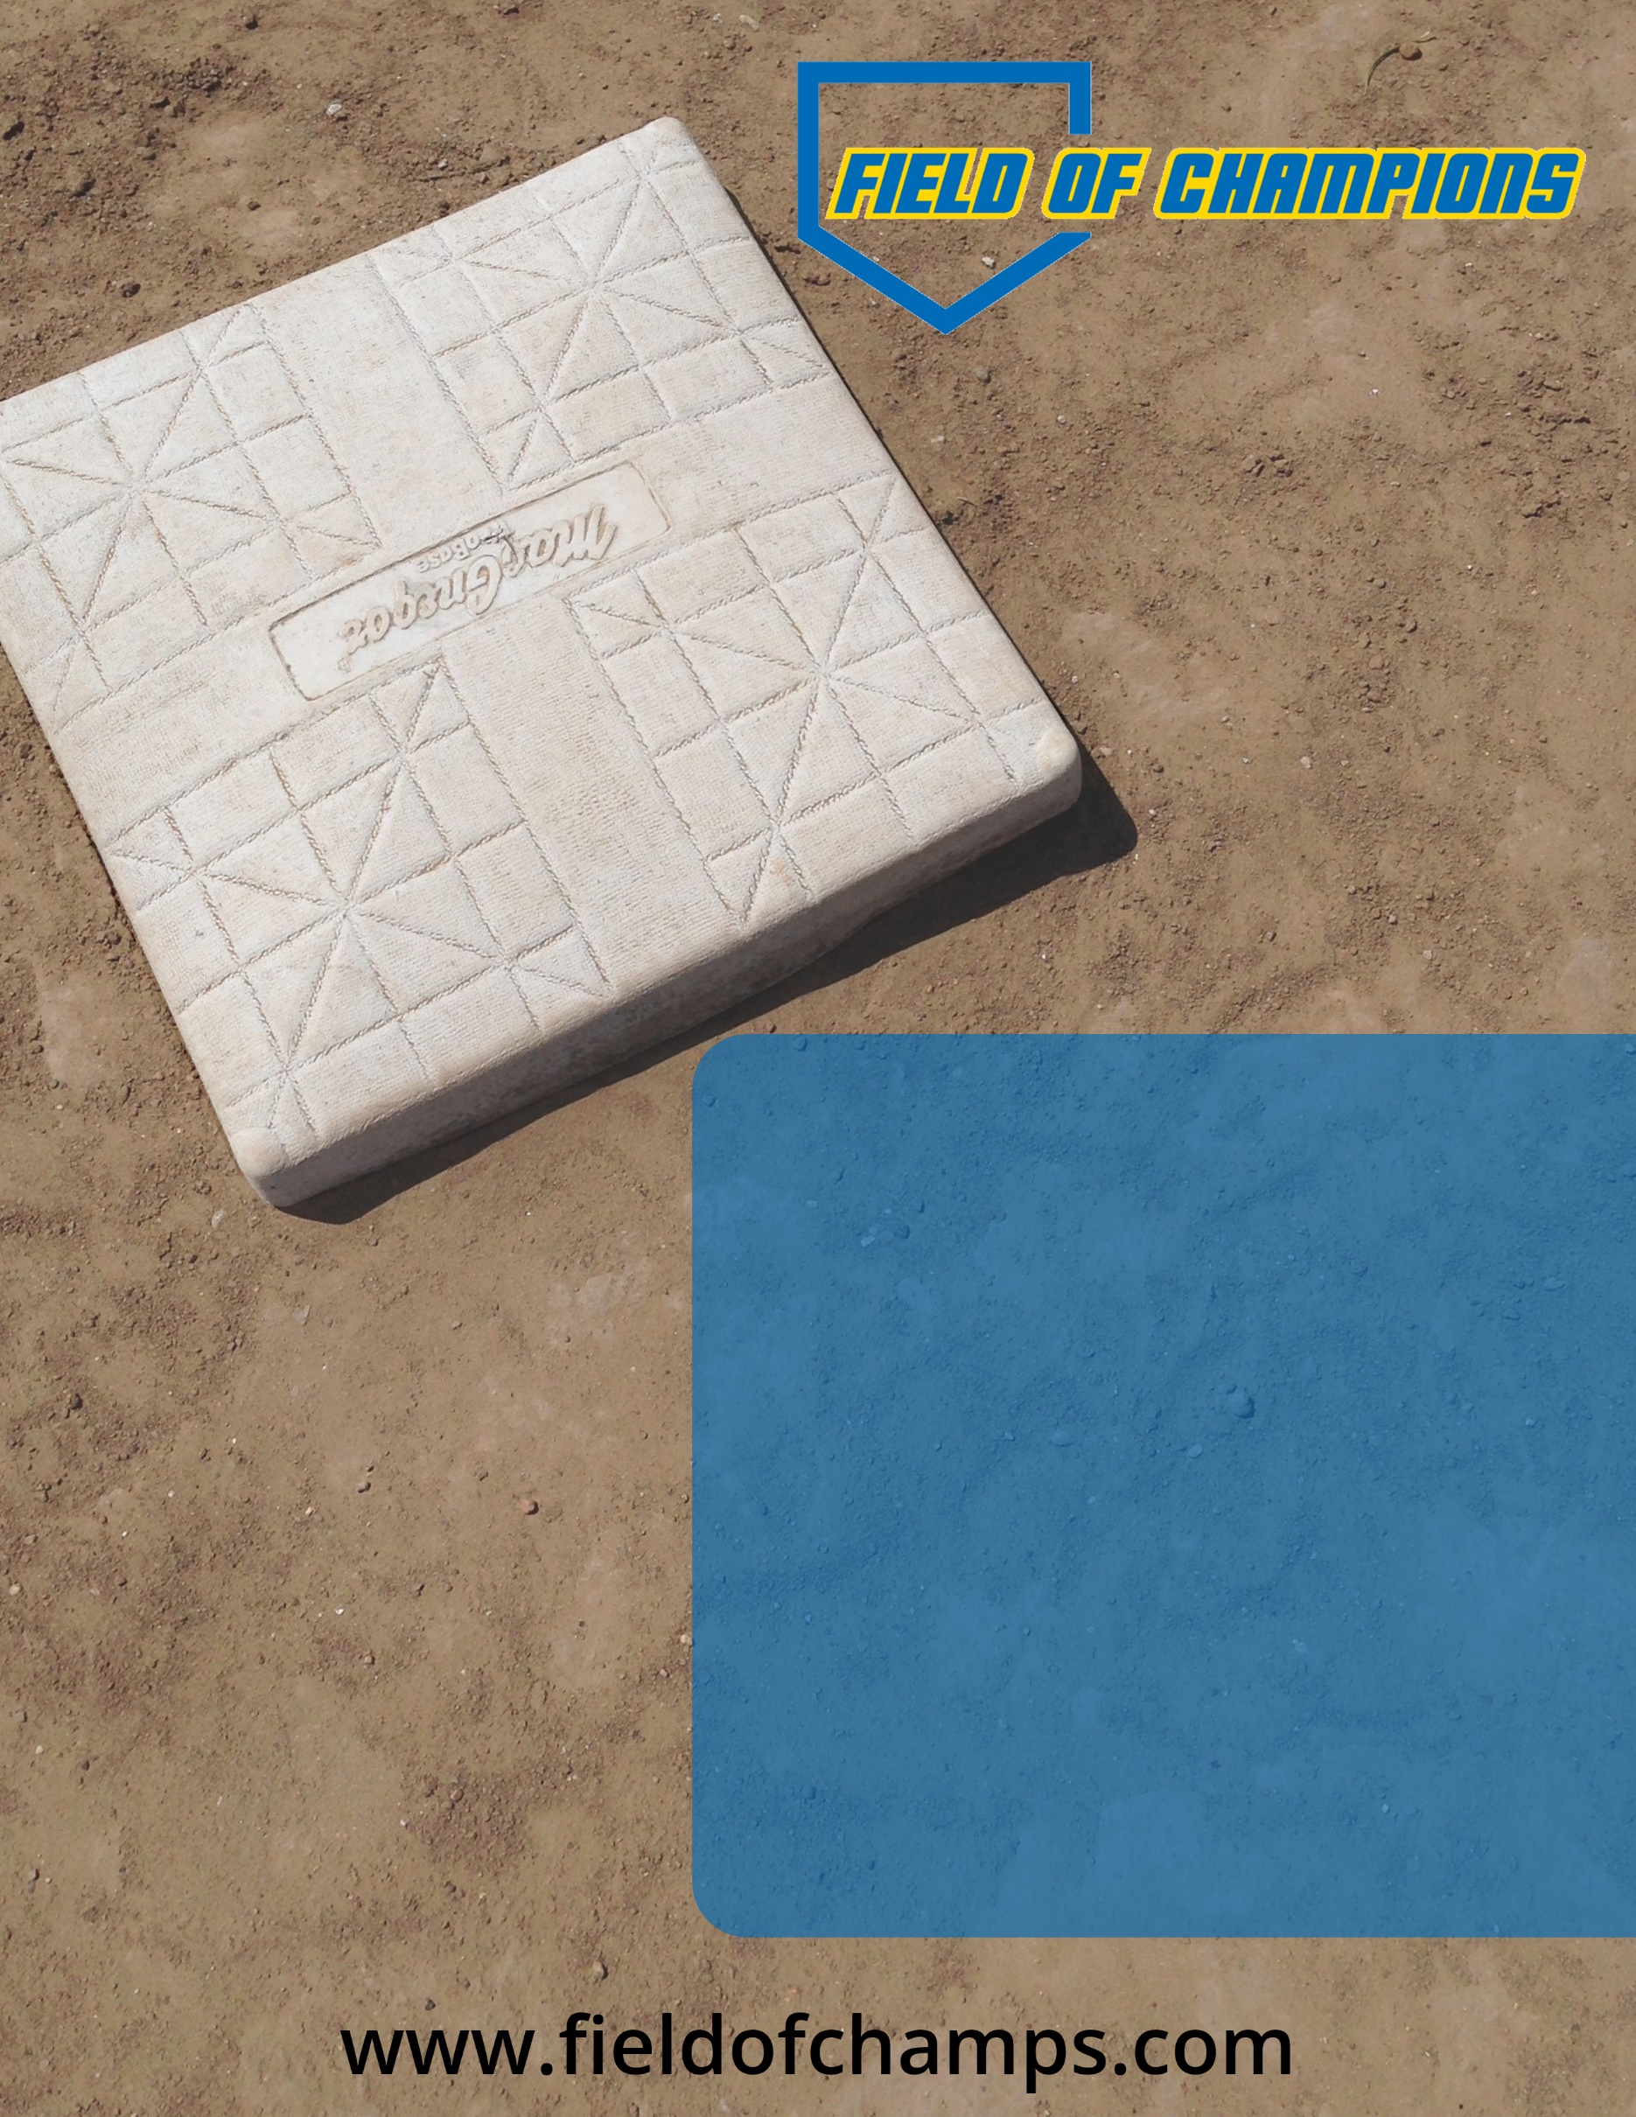­­

**Please pre-register and note which of these try-outs you will attend.**

**To arrange a try-out prior to 7/17, pleae email Alan at bearsbbc@gmail.com**

**July 30 6:00-7:30PM**

**July 17 6:00-7:30PM**

**FOC BEARS ALTERNATE TRY-OUTS 2018-19**

**@ FOC**

**All Ages**

**July 26 6:00-7:30PM**